Tomcat 8.5 Installation

1. Take one Ec2-instance (Amazon Linux (or)Redhat,(or)Ubuntu.
2. In this I am taking Ec2 Amazon Linux.
3. To install java8 please visit the below link and follow the steps as mentioned in that document.

<https://tecadmin.net/install-java-8-on-centos-rhel-and-fedora/>

1. First download the tomcat 8.5 by visiting the below link

<https://tomcat.apache.org/download-80.cgi>

1. After visiting the above link make sure you download tomcat8.5 zip version only

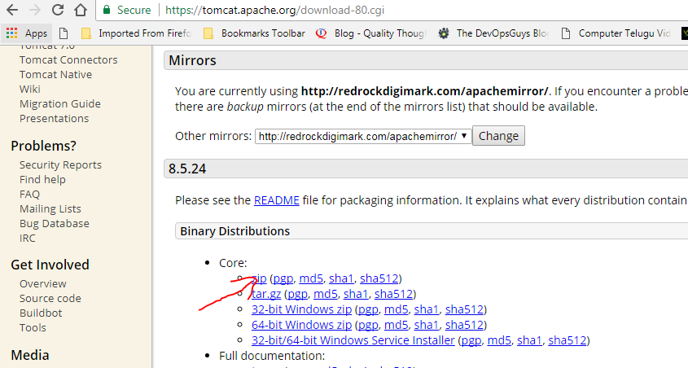

1. Copy the link address and by using wget paste it in ec2 instance.



1. Now one file will be downloaded, unzip the file.
2. After unzip the file pls move to apache directory, then in that directory you will see some files like this.

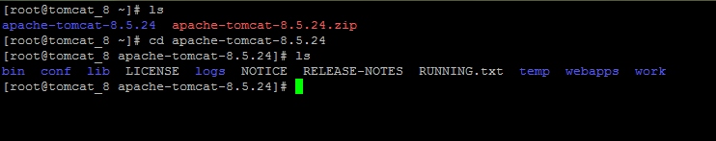

1. Move to Webapps folder

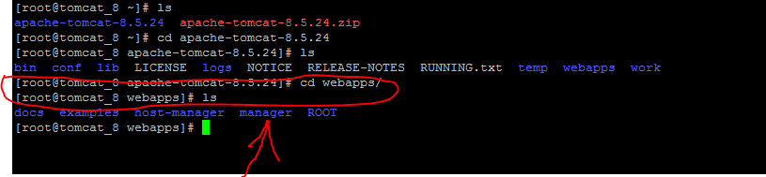

1. There is one more directory by name Manager ,move to that directory

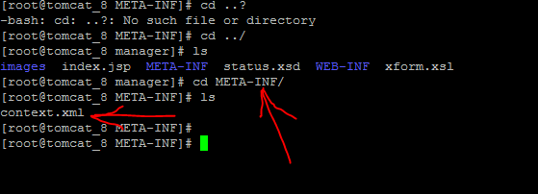

Inside manager directory there is one more directory by name META-INF , move to META-INF directory .There is one more file by name context.xml

Open context.xml file and uncomment as mentioned below

1. Add comments as below and save it

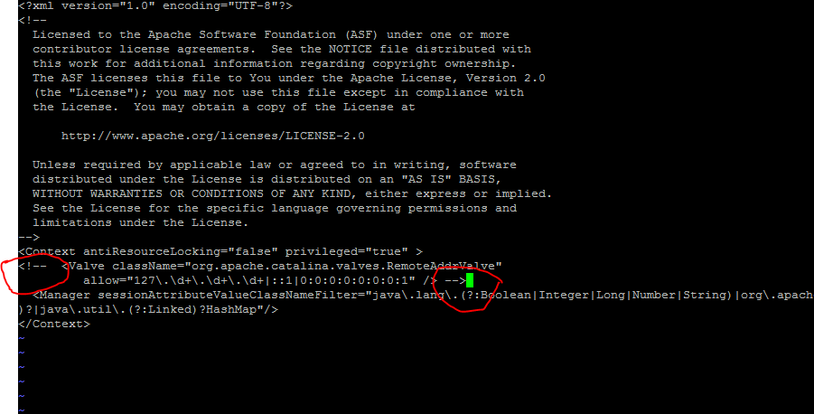

1. Now move to conf directory open the file Tomcat-users.xml and create a user by pasting below data as mentioned below

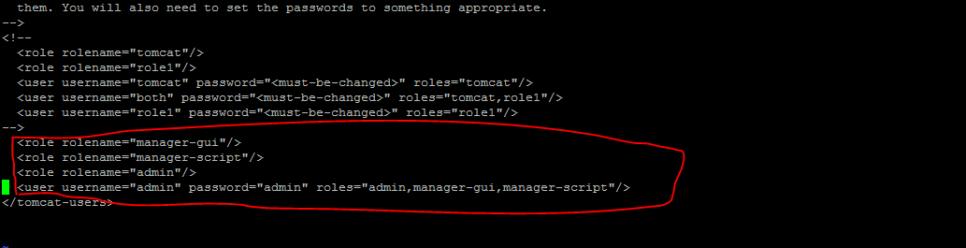

Save the file and exit.

1. Now move to bin directory and type

./shutdown.sh

In my case I got an error like permission denied so I gave 777 permissions

Chmod 777 shutdown.sh

./shutdown.sh

Next type ./startup.sh

Service will be started

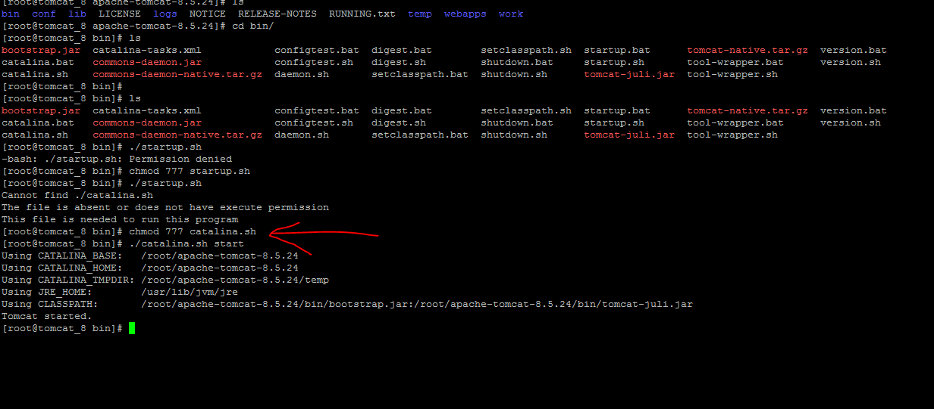

14)

Make sure port number 8080 is open in security group

Open empty tab in Google chrome take the ip address of tomcat and paste:8080

In my case it is http:// <http://13.127.98.153:8080/>

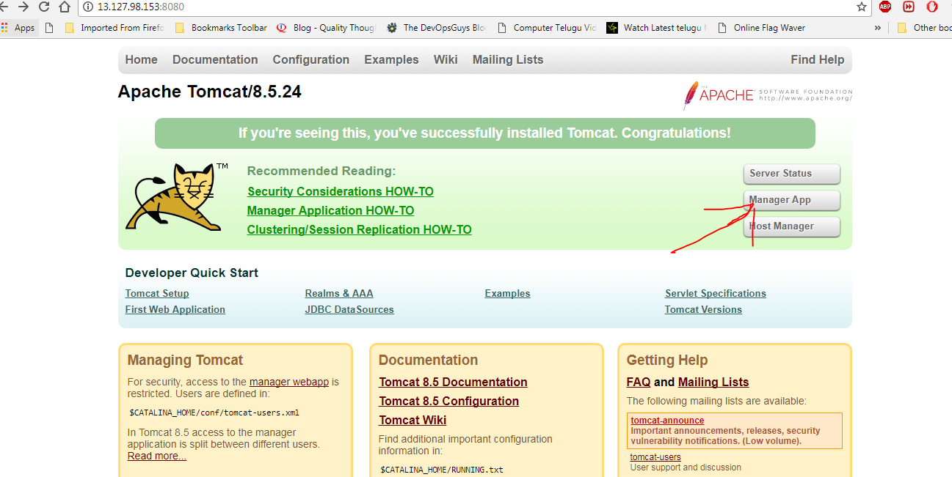

15) If above page is displayed then tomcat is installed successfully

16) We created one user

Username: admin

Password: admin

At right-side click on Manager app enter credentials you will be redirected to different page where you can deploy your war file.

